java Introduction

* java full name just another Accelerator
* java founded in **1995**
* java founder name was **jams gosling**
* java maintenance by **oracle**
* inventor by **sun micro system**
* java using mobile Application Web Application and banking sector .
* java is the most popular language
* **3 billion** device can run the java application

java concept

* variable
* Data type
* java Syntax
* java command line
* java Type casting
* java operators
* java String
* Conditional statement
* java Array
* java Methods
* java OOP concept
* file handing
* Multi threading
* Exception Handing
* Collection

java memory management

(JVM memory Area)

* Heap memory
* Stack memory
* Native method
* Method Area
* Pc Register

JVM,JRE,JDK

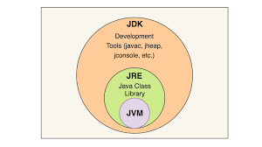

**JVM- java virtual machine**

* **to convert byte code to machine**
* **code line by line execution**
* **code overflow**
* **load the code**
* **verity the code**
* **Execute the code**
* **provide the runtime Environment**

**JRE-** java Runtime Environment

* it contain set of library
* its provide to Runtime Environment
* java program implement to JVM

**JDK- java Development Tool**

* its downloading to file
* there package is kit
* Run the java application
* downloading the tools like JRE

Ex: javac ,javadoc,..etc

difference between Heap and stack

|  |  |
| --- | --- |
| Heap | Stack |
| Reference variable store stack memory | Class and object it can store heap memory |
| Static memory Allocation | Dynamic memory Allocation |
| Fast Execution | Slow Execution |
| Memory Shortage | Memory Fragmentation |